Part 1 - Problem Outline

1. Situation / Context
In 2024, the Financial Conduct Authority (FCA) mandated Lloyds Banking Group to review all historical motor finance agreements (2007 to 2025) and identify customers eligible for compensation. This involved millions of documents stored in semi-structured formats.
Originally, all documents were manually reviewed to extract customer details, key agreement information, and transaction histories.
This process was:
- Extremely time-consuming
- Error-prone, especially for long documents (1–50+ pages)
- Not scalable to meet the December 2025 FCA deadline
A fully automated, reliable, and scalable document intelligence solution was required.

2. Problem Statement
Design and deliver an automated machine learning/document intelligence pipeline that extracts structured information from semi-structured motor finance documents, covering:
- Key-value fields (e.g., customer name, agreement number, date, reference number)
- Tabular fields (e.g., transaction table, fee histories)
The pipeline should convert raw document text files into a consistent, validated, analysis-ready output with minimal human intervention.

3. Users & Output Requirements

Primary user:
The Motor Finance team responsible for compensation assessment.

Key outputs required:
- A structured Excel file containing:
  - All mandatory key-value fields
  - Reconstructed transaction and fee tables
- A validation sheet showing:
  - Field-level pass/fail against business rules
  - Flags for inconsistent, low-confidence, or missing fields

4. Success Metrics
- ≥90% accuracy on all mandatory fields
- 60% reduction in manual processing time
- 90% reduction in human review (only exceptions / failed validations)
- 300k+ documents processing before September 2025.

Part 2 - Architecture Diagram Description

Inference Pipeline Component

Model Strategy: Why LiLT?

LiLT (Language-Independent Layout Transformer) model was selected over standard LayoutLM or Dount, or LLM models for the following reasons:

- Efficiency (.txt Compatible): Unlike LayoutLM or Donut, which require image inputs, LiLT accepts text and synthetic coordinates directly. This eliminates the need to render .txt files into images, reducing pre-processing latency.
- Compliance (Zero Hallucination): The high accuracy was a big requirement from the stakeholders. LiLT is a discriminative model (token classification), meaning it extracts existing text rather than generating new words. This eliminates the risk of "hallucination" inherent in LLMs.
- Layout Invariance: The 2D spatial embeddings allow LiLT to understand structure (e.g., distinguishing a "Total" in a table footer from a paragraph text), which is critical for handling documents that can spread across multiple pages.
- Transfer Learning Efficiency: LiLT is pre-trained on massive corpora of document layouts (e.g., invoices, receipts). This allowed us to achieve high accuracy on our motor finance agreements with minimal fine-tuning (using a small labelled dataset), as the model already understood the inherent structure of semi-structured forms.
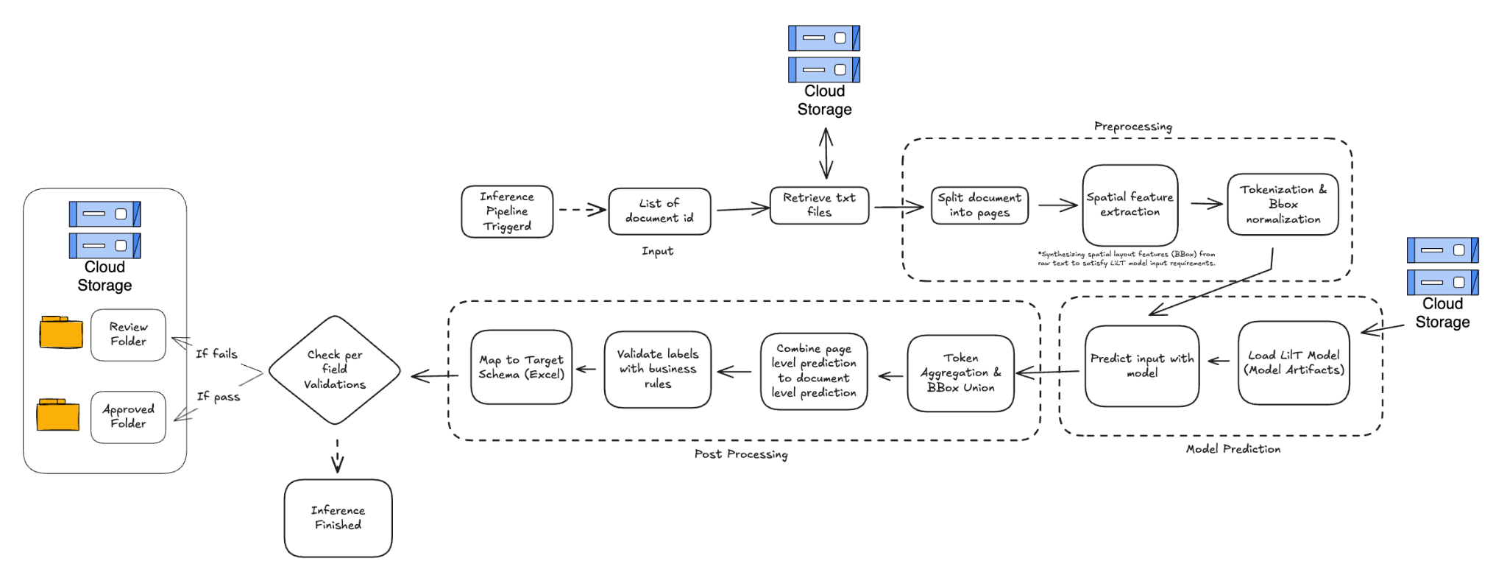

1. Inference Pipeline Workflow
A. Data Ingestion
Assumption: Input data is provided strictly in .txt format.
Libraries: google-cloud-storage
Description: The pipeline accepts a list of Document IDs rather than raw payloads. It retrieves the actual file content from Google Cloud Storage (GCS) only when execution begins. This "Pass-by-Reference" pattern ensures the pipeline payload remains lightweight and reduces network overhead during orchestration.

B. Preprocessing
Assumption: Documents contain multi-page data separated by a specific token (e.g., ? in provided data).
Libraries: torch, transformers, numpy
Description:
Page Splitting: Raw text is split into page-level chunks using the designated separator token to manage the model's sequence length limits.
Spatial Feature Engineering: Since .txt files lack native layout coordinates, we implement a heuristic engine to synthesise Bounding Boxes (BBoxes) based on character positioning. This is critical to satisfy the spatial input requirements of the LiLT model.
Tokenization & Alignment: Words are split into sub-word tokens using the XLM-RoBERTa tokenizer. We utilise index mapping to propagate the synthetic BBoxes to each sub-token, ensuring the spatial features align perfectly with the model's vocabulary.

C. Model Prediction
Assumption: Fine-tuned model artifacts are versioned and stored in a GCS bucket.
Libraries: torch, transformers, google-cloud-storage
Description:
Artifact Loading: Due to specific infrastructure constraints (Model Garden unavailability), the pipeline retrieves specific model version artifacts (weights/config) from GCS to the local node at runtime.
LiLT Inference: The model performs token classification using both textual features and the synthetic spatial layout. This dual-modal approach allows LiLT to distinguish entities based on position (e.g., table headers vs. body text) despite the unstructured format.
Output: The model returns token-level label IDs and associated confidence scores (Logits).

D. Post-Processing & Logic
Assumption: Business rules for field formats and table accounting are pre-defined.
Libraries: openpyxl, pandas, numpy, regex
Description:
Entity Reconstruction: Sub-word tokens are aggregated back into full words. The label with the highest confidence score is assigned to the reconstructed entity.
Tabular Alignment: Disjointed predictions are re-aligned into structured rows and columns to form a coherent DataFrame.
Heuristic Correction: To boost recall, we implemented a programmable logic layer to handle "Gap Filling." If the model misses a cell in a table structure, the logic infers the missing value based on row/column alignment.
Validation Layer: A deterministic rules engine verifies the output.
Key-Value: Regex pattern matching (e.g., Agreement Number format).
Tabular: Arithmetic consistency checks (e.g., Transaction amounts must sum to 0).

E. Output Mapping & Storage
Libraries: google-cloud-storage
Description:
Mapping: Results are serialised into an Excel file containing the extracted data and a dedicated "Validation Report" sheet.
Intelligent Routing: The pipeline acts as a filter.
Path A (Approved): If all validations pass, the file is moved to the Approved folder.
Path B (Review): If any key validation fails, the file is routed to the Review folder. This granular routing allows human reviewers to focus solely on problematic documents.

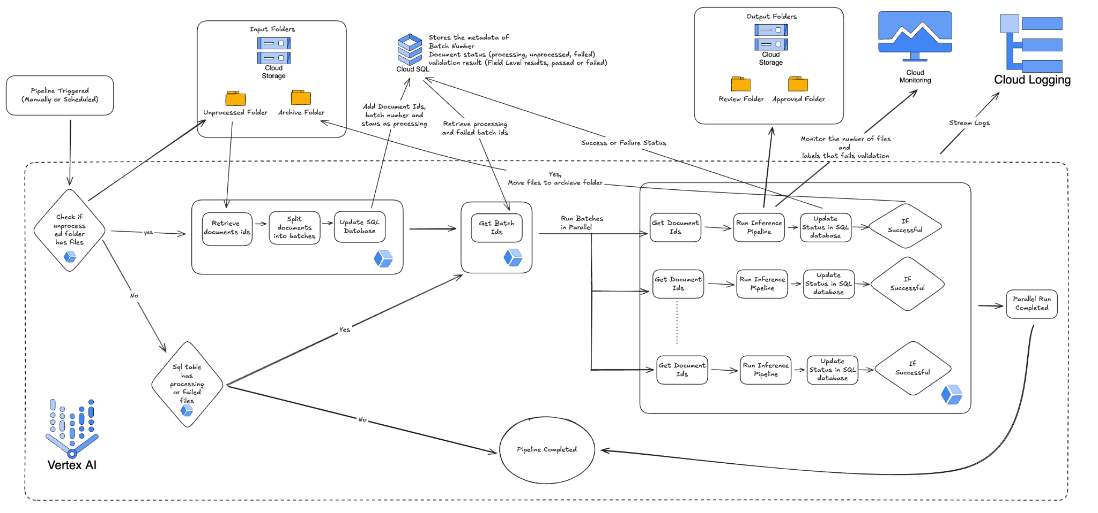

2. Deployment & Orchestration Pipeline (Vertex AI)
A. Orchestration & State Management
Assumption: A Cloud SQL instance is provisioned and accessible for the project from the Vertex AI Pipeline.
Services: Vertex AI Pipelines (Kubeflow), Cloud SQL, Google Cloud Storage
Description:
State-Aware Execution: The pipeline is not stateless; it interacts with a Cloud SQL database to track the status of every batch (PROCESSING, COMPLETED, FAILED).
Idempotency: Before processing triggers, the pipeline queries the database. This allows it to resume from the exact point of failure in case of system interruptions, preventing duplicate processing and ensuring robust fault tolerance.

B. Ingestion & Batch Creation
Assumption: Input files arrive in a designated "Landing" bucket.
Services: Google Cloud Storage (GCS)
Description:
Data Storage: Upon ingestion, raw files are first moved to the unprocessed folder, where the pipeline identifies the arrival of a new document batch, and once the files are processed successfully, they are then moved to the Archive folder to ensure that files are not lost and can be audited in future if required.
Batch Creation: The pipeline identifies available files and groups them into logical batches. Metadata for these batches (IDs, file paths) is logged to Cloud SQL, and only the lightweight Batch IDs are passed downstream, minimising metadata overhead.

C. Dynamic Scaling (The "Fan-Out" Architecture)
Assumption: Infrastructure availability to support running multiple components.
Services: Vertex AI, Artifact Registry
Description:
Parallel Execution: We utilise the dsl.ParallelFor construct to implement a "Fan-Out" pattern. The pipeline iterates over the list of Batch IDs and dynamically provisions a separate worker node for each batch. A retry mechanism was also configured for all the components in case of unexpected failure.
Ephemeral Compute: Each worker node is an ephemeral container pulling the specific model image from the Artifact Registry. We selected the GCP n2d-standard-16 machine for the inference step and the n2d-standard-8 machine for the rest to optimise the cost-to-performance ratio, ensuring the 300k document workload completes within the 6-hour window.

D. Observability & Routing
Assumption: Log sinks are configured to export high-severity errors.
Services: Cloud Logging, Cloud Monitoring
Description:
Validation-Based Routing: The pipeline acts as a logic gate. Based on the "Pass/Fail" signal from the inference step, it routes the final Excel outputs to either an Approved folder (ready for downstream consumption) or a Review folder (triggering human intervention).
Proactive Monitoring: We stream application-level logs (e.g., validation failure rates) and system-level logs to Cloud Monitoring. Alerts are configured to notify the engineering team if the ratio of "Failed Batches" exceeds a pre-defined threshold, allowing for rapid response to data drift or infrastructure issues.

Part 4 - Evaluation Strategy

A. Development Evaluation

1. Field-Level Evaluation
A labelled test dataset was used to compare model predictions against ground-truth annotations.
Since the model performs token classification (does not generate new text), exact string match accuracy was used for each field. This provided a strict and reliable measure of correctness.

2. Table Evaluation
Two metrics were applied for table extraction:
- Fully Correct Table: All rows and columns match the labelled table exactly.
- Partially Correct Table (Row Accuracy): Percentage of rows predicted exactly correctly.
This combination helped identify structural errors and pinpoint where table extraction struggled.

B. Production (Online) Evaluation

1. Business Rule Validations
Field-level validation rules—agreed with the Motor Finance business team, were applied to check:
- Format (dates, IDs, amounts)
- Cross-field consistency
- Mandatory field presence
- Table validation rules, such as transaction aggregation consistency.
Fields were classified as pass or fail

2. Monitoring Validation Failures
Field-level failure trends were monitored to detect:
- Field-level extraction issues
- Documents needing escalation

3. Human Review
Only fields or documents that failed critical validations were routed to human review, ensuring high accuracy while minimising manual effort.

